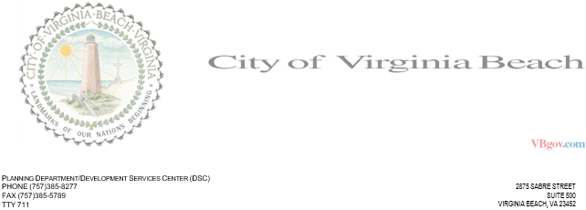

INTER-OFFICE MEMORANDUM **DATE:** 05/17/2021 **TO:** Mark **FROM:** travis **SUBJECT:** Some Project  
 DSC Engineering Review Comments  
 DSC File: 2020

DSC cannot approve the project at this time. The following comments must first be addressed:  
  
1: SAVED A COMMENT. ((VESCH 3.09).)  
2: PROVIDE THE DANG PLAN. (Guide to Commercial Site Plan Development.)